**Code used for the project:**

**1.Tinkercad code(Circuit):**

#include <LiquidCrystal.h>

const int PIN_RED = 5;

const int PIN_GREEN = 6;

const int PIN_BLUE = 7;

float d = A0;

int celsius = 0;

int fahrenheit = 0;

String ssid = "Simulator Wifi"; // SSID to connect to

String password = ""; // Our virtual wifi has no password

String host = "api.thingspeak.com"; // Open Weather Map API

const int httpPort = 80;

String uri = "/update?api_key=IWIDWLTZC9V2SCV3&field1=0";

int setupESP8266(void) {

// Start our ESP8266 Serial Communication

Serial.begin(115200); // Serial connection over USB to computer

Serial.println("AT"); // Serial connection on Tx / Rx port to ESP8266

delay(10); // Wait a little for the ESP to respond

if (!Serial.find("OK")) return 1;

// Connect to 123D Circuits Simulator Wifi

Serial.println("AT+CWJAP=\"" + ssid + "\",\"" + password + "\"");

delay(10); // Wait a little for the ESP to respond

if (!Serial.find("OK")) return 2;

// Open TCP connection to the host:

Serial.println("AT+CIPSTART=\"TCP\",\"" + host + "\"," + httpPort);

delay(50); // Wait a little for the ESP to respond

if (!Serial.find("OK")) return 3;

return 0;

}

void anydata(void) {

int temp = map(analogRead(A0),20,358,-40,125);

// Construct our HTTP call

String httpPacket = "GET " + uri + String(temp) + " HTTP/1.1\r\nHost: " + host + "\r\n\r\n";

int length = httpPacket.length();

// Send our message length

Serial.print("AT+CIPSEND=");

Serial.println(length);

delay(10); // Wait a little for the ESP to respond if (!Serial.find(">")) return -1;

// Send our http request

Serial.print(httpPacket);

delay(10); // Wait a little for the ESP to respond

if (!Serial.find("SEND OK\r\n")) return;

}

void setup() {

pinMode(PIN_RED, OUTPUT);

pinMode(PIN_GREEN, OUTPUT);

pinMode(PIN_BLUE, OUTPUT);

pinMode(A0, INPUT);

Serial.begin(9600);

setupESP8266();

}

void loop() {

//normal temp i.e. 97.7-99.5 F : 36.5 -37.5 C

float MinTemp=35.0; //less than usual i.e. <95 F

float MaxTemp=37.6; //fever i.e. >99.5

celsius = map(((analogRead(A0) - 20) * 3.04), 0, 1023, -40, 125);

fahrenheit = ((celsius * 9) / 5 + 32);

//to print degree fahrenheit

Serial.print(fahrenheit);

Serial.print(char(176));

Serial.print(" F (");

//to print degree celsius

Serial.print(celsius);

Serial.print(char(176));

Serial.println(" C)");

if (celsius < MaxTemp && celsius > MinTemp){

analogWrite(PIN_RED,0);

analogWrite(PIN_GREEN,204);

analogWrite(PIN_BLUE, 0);

delay(500);

}

else if (celsius >= MaxTemp ) {

analogWrite(PIN_RED,204);

analogWrite(PIN_GREEN, 0);

analogWrite(PIN_BLUE, 0);

delay(500);

}

else{

analogWrite(PIN_RED,0);

analogWrite(PIN_GREEN, 0);

analogWrite(PIN_BLUE,204);

delay(500);

}

anydata();

}

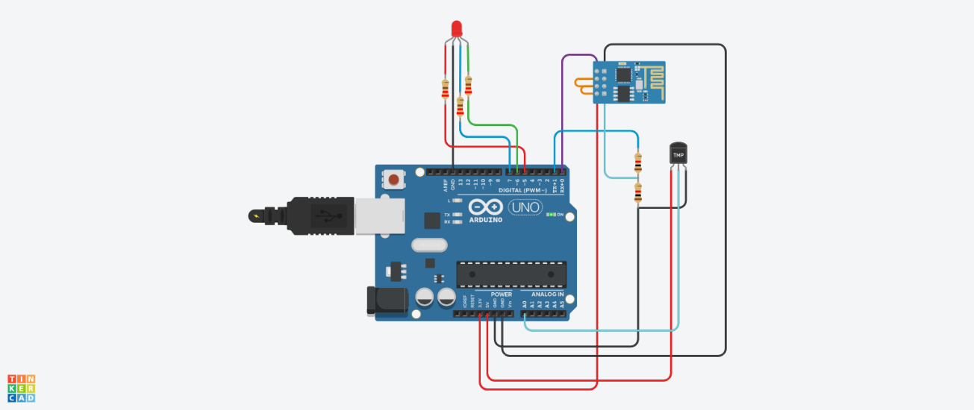

**2.Thingspeak(Iot-Cloud platform):**

